X00160711 Cianan Nicolai,X00161872 Elijel De La Cruz

Android/ASP.Net Core Web API CA2 Report - Draft TOC

Contents

Github - repo URI, use of repo, commits etc. 2

URI of demo video 2

Database – schema 2

Service 3

Short description of operations 3

Screenshot of swagger UI test page 3

how it has been deployed e.g. Azure app service settings 5

App 5

Internationalization 5

Miscellaneous 5

# Github - repo URI, use of repo, commits etc.

URL - <https://github.com/CiananNicolai/EAD2CA2-Android-ASP.Net-Core-Project.git>

Commits – 40

App UI, Elijel

RestaurantAPI, Cianan

Report, Cianan

Azure Hosting, Elijel

# URI of demo video

# Database – schema

Schema

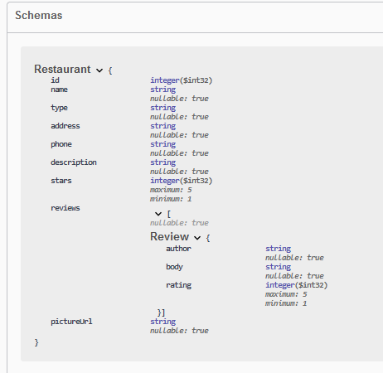

# Service

URL - https://restarauntapica2.azurewebsites.net/swagger/index.html

## Short description of operations

Android Application coded in Java. Service is launched on Azure, which provides the API which it calls information from. Makes use expresso. Internationalization available in German.

## Screenshot of swagger UI test page

Functions include, get for restaurants and reviews, post for reviews, delete for reviews and searching by type.

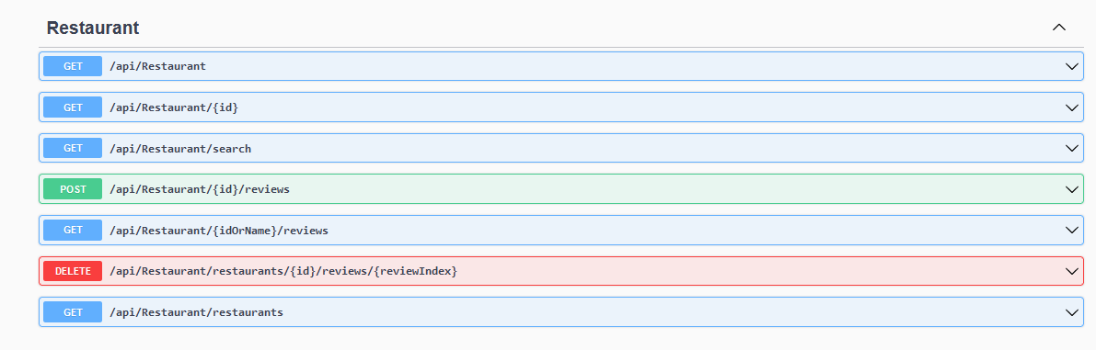

All Function

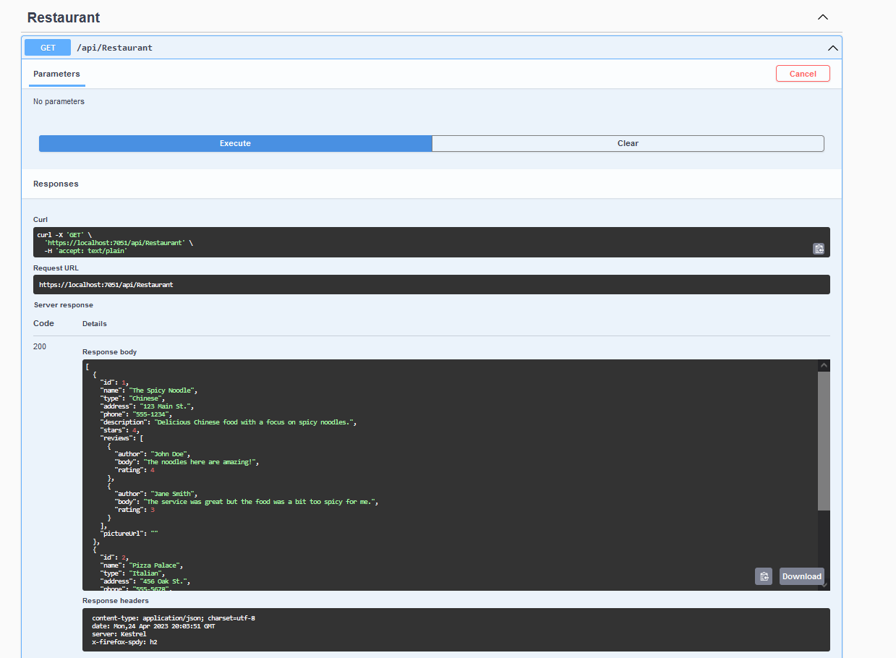

Postman HTTP request

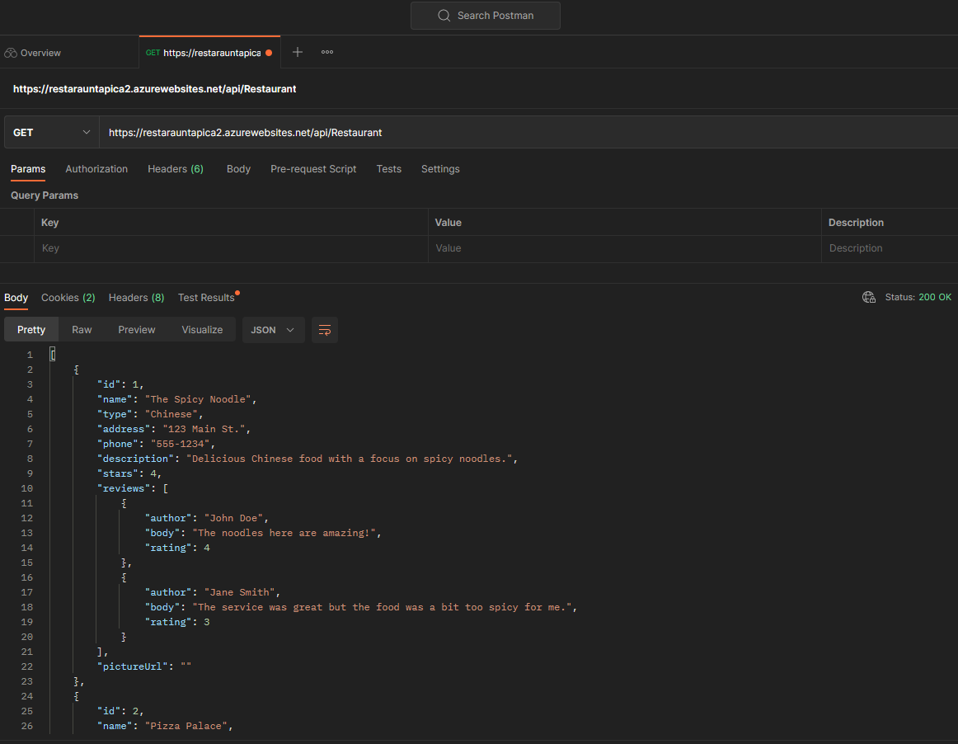

how it has been deployed e.g. Azure app service settings   
  
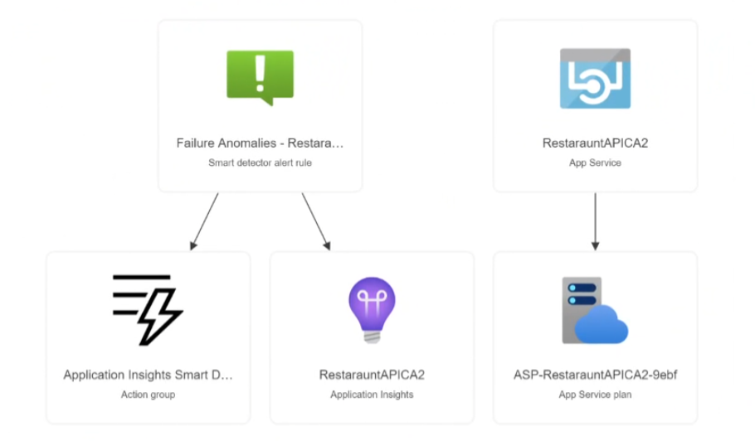

# App

## Screen Shots

## Expresso Tests

This test checks for the name of the restaurant when going inside it’s details.

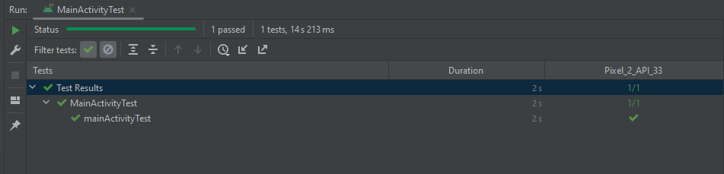  
  
This test fails because it cannot wait for the text inside the textbox to load and says that it’s empty. It’s there but we’re unsure how to improve it.  
  
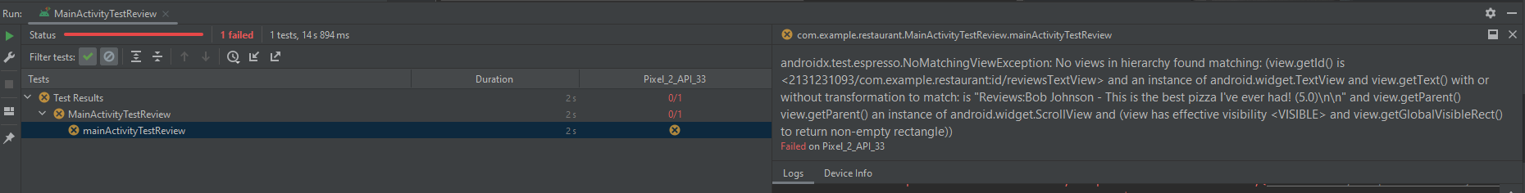  
  
Test that checks if it’s creating a list of two restaurants.

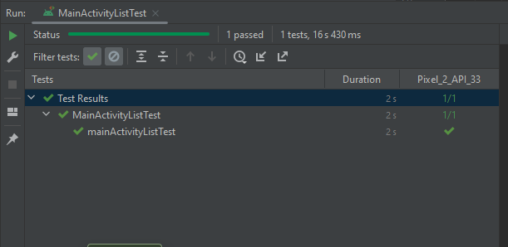

## Internationalization

German

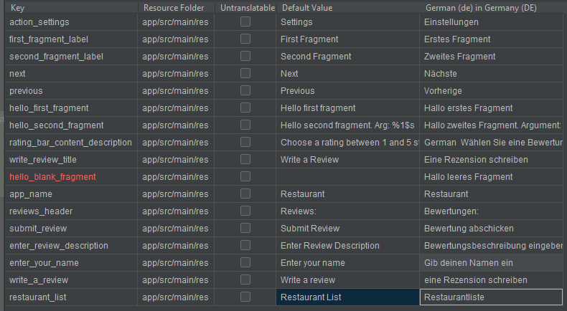

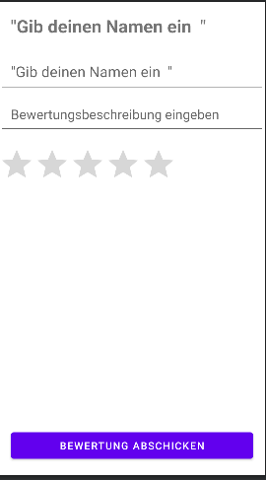

# Miscellaneous

– code quality analysis